Setting up new clients for edit2021

# Create Local Client Directories

On xampp/htdoc

client_app -- copy all except content from another client & then modify

client_prototype – copy all except content from another client & then modify

# Create Local Database

Copy another client

Erase Content and Members (keep reference databases)

# Create Remote Database

# Create Remote Directories

Client – needs SSL

Client.edit -- – copy all except content from another client & then modify

Clien.prototype – needs SSL; – copy all except content from another client & then modify

# VueJS Environmental Variables

Set up both local and remote variables

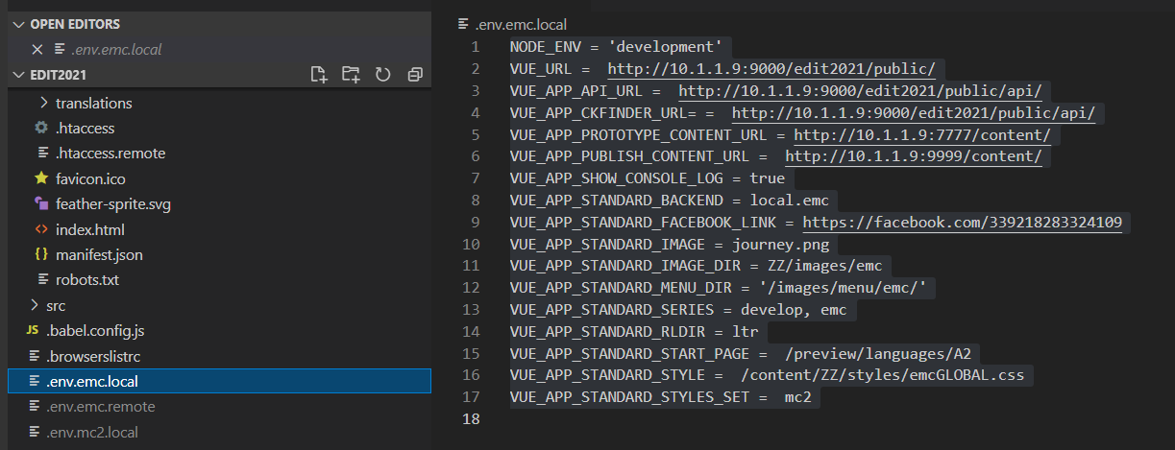

# API Environmental Variables

Set both local and remote .env files

Also make directories for php files unique to this client

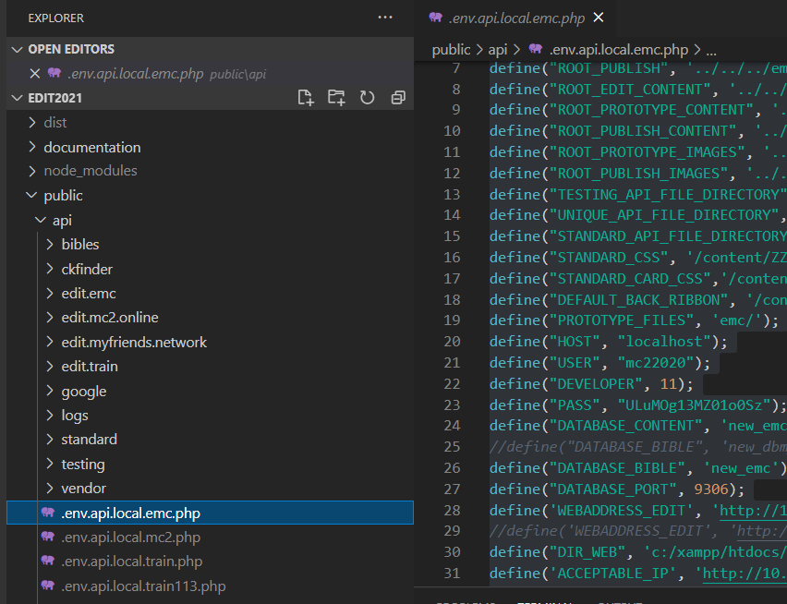

# CKEDITOR

Make any changes to the styles here.

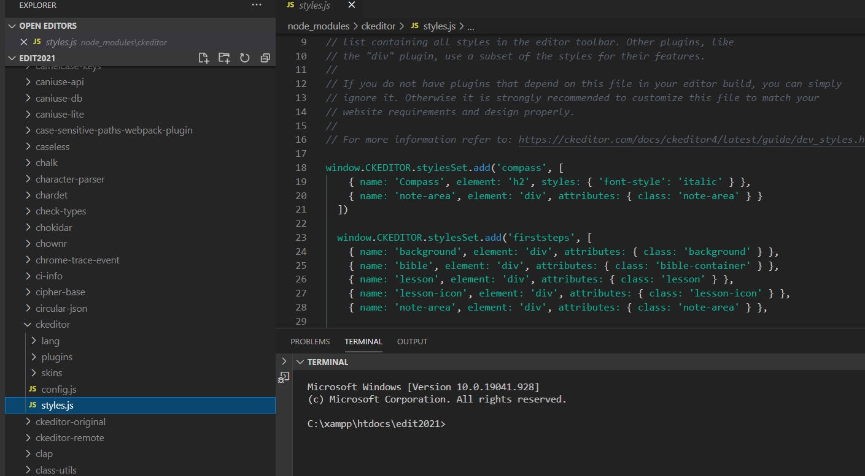

# CKFINDER

Set content/files and content/images

You will need to adjust the settings in this file

Also make sure you set :

'authentication' => function () {

return true;

},

You will find the location of this in your .env.SITE.remote file   
 Look for the setting of VUE_APP_SITE_CKFINDER_URL  
 Normally VUE_APP_SITE_CKFINDER_URL = WEBSITE_URL/sites/SITE/ckfinder/

<https://edit.mc2.online/sites/mc2/ckfinder/core/connector/php/vendor/cksource/ckfinder/src/CKSource/CKFinder/Config.php>

/*=================================== Backends ========================================*/

// https://ckeditor.com/docs/ckfinder/ckfinder3-php/configuration.html#configuration_options_backends

$config['backends'][] = array(

'name' => 'default',

'adapter' => 'local',

'baseUrl' => '/sites/myfriends/content/',

// 'root' => '', // Can be used to explicitly set the CKFinder user files directory.

'chmodFiles' => 0777,

'chmodFolders' => 0755,

'filesystemEncoding' => 'UTF-8',

);

/*================================ Resource Types =====================================*/

// https://ckeditor.com/docs/ckfinder/ckfinder3-php/configuration.html#configuration_options_resourceTypes

$config['defaultResourceTypes'] = '';

$config['resourceTypes'][] = array(

'name' => 'Files',

'directory' => 'files',

'maxSize' => 0,

'allowedExtensions' => 'bmp,gif,jpeg,jpg,png',

'deniedExtensions' => '',

'backend' => 'default'

);

$config['resourceTypes'][] = array(

'name' => 'Images',

'directory' => '',

'maxSize' => 0,

'allowedExtensions' => 'bmp,gif,jpeg,jpg,png',

'deniedExtensions' => '',

'backend' => 'default'

);

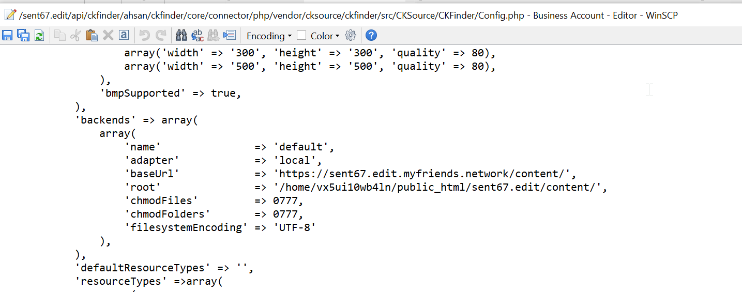

## .htaccess

Find an existing one and modify

# ckEditStyleSets

consider adding a new Style Set and Templates

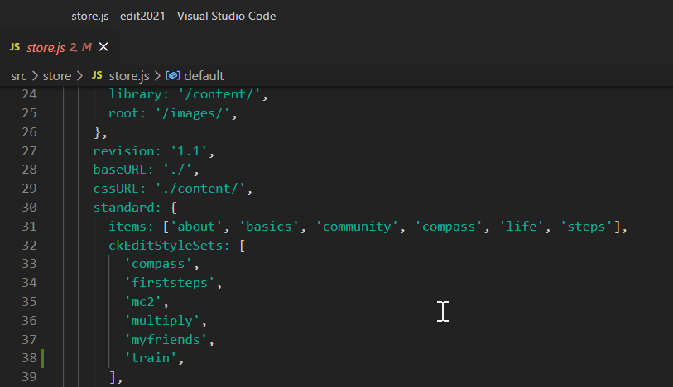

It is easier to create an html file and then change it to js using the following substitutions:

< replaced by \x3c

= replaced by \x3d

> replaced by \x3e

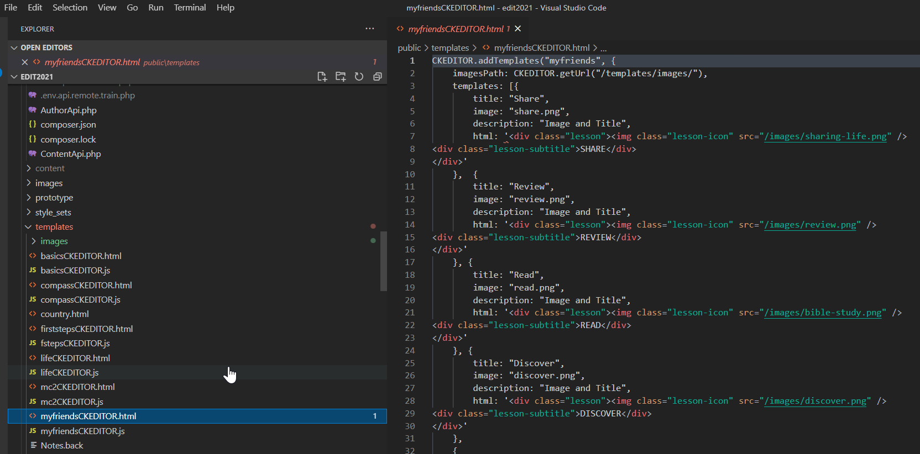

# Create .env files

# Update package.json

